

**Record Store**

**E-Project Documentation**

**Teacher Name: Miss Mahnoor Tahir**

**APTECH COMPUTER EDUCATION**

**HYDERABAD-1 PAKISTAN**

**Issue Date: 11-oct-2023**

TABLE OF CONTENT

|  |  |  |
| --- | --- | --- |
| **S No** | **Contents** | **Page No** |
| 01 | Certificate | 3 |
| 02 | Acknowledgement | 4 |
| 03 | Project Report | 5 |
| 04 | Problem Definition | 6 |
| 05 | Customer Requirements Specification  (CRS) | 7 |
| 06 | Architecture Design of the Project | 8 |
| 07 | System Requirement | 9 |
| 08 | Task Sheet | 10 |
| 09 | Project Plan | 11 |
| 10 | Checklist of work Progress | 12 |
| 11 | Final Check List | 13 |
| 12 | Screen Shots | 14 |
| 13 | Source Code | 16 |

CERTIFICATE

This is to certify that

**MUHAMMAD BHAKTAWAR SIDDIQUI and TOUQEER QURESHI**

Submitted by:

**ALL GROUP MEMBERS**

Has successfully Designed

Record Store

Date of Issue: **11-oct-2023**

Authorized Signature:

Miss Mahnoor Tahir

ACKNOWLEDGEMENT

First and foremost, we would like to express our deep gratitude and most heartfelt thanks to almighty ALLAH for his blessings, for lightening up our heart with the torch of knowledge and for giving us the ability to complete this project.

We would like to thanks Aptech Worldwide and the team of E-Project for their generous support and clarifying the doubts regarding e-project. We would like to acknowledge the way of explanation which the team of e-project gave in e-project to make website and we are equally grateful to our teacher (Miss Mahnoor) for giving us a moral support and guiding us different matters regarding project in all the time about the research and writing of this project.

We are greatly indebted to Aptech Worldwide, Miss Mahnoor, Faculty Members and ACE Hyderabad, Pakistan for encouragement and incessant help.

PROJECT REPORT

**BY:**

**Student1484199 MUHAMMAD BHAKTAWAR SIDDIQUI**

**Student1484197 TOUQEER QURESHI**

Project Title: Record Store

Members Name: Muhammad Bhaktawar Siddiqui, Touqeer Qureshi

Batch Code: 2306E

Start Date: 11-oct-2023

End Date: 2-nov-2023

Course: ACCP-PRIME (CPISM)

Teacher: Miss Mahnoor Tahir

Center Manager: Sir Shoaib Ahmed

Center Academic Head: Sir Zubair

Center Name: ACE Hyderabad-1, Pakistan

Submitted as

E Project Documentation

**PROBLEM STATEMENT**

Rhythm House is a music store in the city which offers not only music but contests and live shows too. It caters to almost all the age groups by providing the CDs, tapes of poems for kids, latest pop music collection for teenagers etc. Rhythm House also caters to a slightly older age group and boasts of the largest collection of regional and devotional music. Besides, if someone wants to pick up a good 60's or 70's rock album, chances are that he will get it here, and in case it’s not available, they will order it within a week.

They have the largest tape collection one can find ranging from Motion Picture Soundtracks to Rock 'n Roll. Besides music, one can find a number of music related magazines on sale. While some magazines are Indian, most of them are Air Mailed from the US and include top magazines like Guitar Legends and Total Guitar.

They also have a membership facility where in you can enroll yourself against any purchase of Rs. 200 and for subsequent purchases you can avail of points and other offers.

Looking at the growing competition, they have decided to find an easy source to reach to the customer and the solution they thought of is of building a web site which will host all the information about their shop.

They have approached you to develop site by the name rhythmhouse.com for them. The site needs to be developed based on the following set of requirements.

Requirement Specification:

A menu that will categorize all the functions of the site

Display the list of available albums category wise.

Albums can be of movies or different bands or solo performer’s collections.

Categories can be CD, DVD, Tape as well as movies, bands, Solo performers. E.g there can be CD of a movie as well as DVD and tape, all should be displayed separately.

Perform the search based on a particular

1. movie

2. band

3. solo performer

4. release year

Display the statistics of albums sold monthly.

Display the various offers/contests by the shop

Display the details (performer, time, duration, entry fee etc) of live shows

Give information about membership.

Display the available books and magazines.

Display the price list of the various items available in the shop i.e. (CDs, DVDs, Tapes, Books, Magazines)

Display the schedule and details of upcoming live shows.

Site should be able to provide brief introduction/history about the shop under AboutUs page

The location of the shop under Contact-Us page.

Besides the above requirements, the site should have look and feel as per the industry standards

Architecture & Design of the Project:

Since the website will have client architecture it will have one-tier architecture.

System Requirement:

|  |  |  |
| --- | --- | --- |
| **SR.No** | **Items** | **Description** |
| 01 | Operating System | Window XP, Win7 or win8 |
| 02 | Main Processor | Minimum 2ghz or better |
| 03 | Ram (Memory) | Minimum 512mb or better |
| 04 | Web Browser | Google Chrome or Firefox (Latest) |
| 05 | Software | Notepad, HTML editor, Adobe Dreamweaver CS5.5 |

TASK SHEET

|  |  |  |  |  |  |
| --- | --- | --- | --- | --- | --- |
| **Project Ref. No:** | | **Date of Preparation of Activity Plan:** | | | |
| SR.  No | Task | Actual  Start  Date: | Actual  Day: | Team  Mates  Names: | Status: |
| 01 | Meeting | 12-oct-2023 | 1 | MUHAMMAD BHAKTAWAR SIDDIQUI  TOUQEER QURESHI |  |
| 02 | Data  Collection | 13-oct-2023 | 1 | MUHAMMAD BHAKTAWAR SIDDIQUI  TOUQEER QURESHI |  |
| 03 | Designing  Home  Page | 13-oct-2023 | 5 | MUHAMMAD BHAKTAWAR SIDDIQUI  TOUQEER QURESHI |  |
| 04 | Linking | 14-oct-2023 | 1 | MUHAMMAD BHAKTAWAR SIDDIQUI  TOUQEER QURESHI |  |
| 05 | Check  Links | 15-oct-2023 | 1 | MUHAMMAD BHAKTAWAR SIDDIQUI  TOUQEER QURESHI |  |
| 06 | Designing Menu Page | 16-oct-2023 | 4 | MUHAMMAD BHAKTAWAR SIDDIQUI  TOUQEER QURESHI |  |
| 07 | Designing Other Pages | 20-oct-2023 | 8 | MUHAMMAD BHAKTAWAR SIDDIQUI  TOUQEER QURESHI |  |
| 06 | Finalizing | 30-oct-2023 | 1 | MUHAMMAD BHAKTAWAR SIDDIQUI  TOUQEER QURESHI |  |
| 08 | Documentation | 1-nov-2023 | 1 | MUHAMMAD BHAKTAWAR SIDDIQUI  TOUQEER QURESHI |  |
| 09 | Uploading | 2-nov-2023 | 2 | MUHAMMAD BHAKTAWAR SIDDIQUI  TOUQEER QURESHI |  |

PROJECT PLAN

* Website is able to execute quickly.
* The color combination of our website is so attractive.
* The collection of data is authentic and taken by the most popular product websites.
* Background of each page is as same as the main page.
* The contact page is well prepared exactly for the same page as user clicks on the link...
* A user can resolve its difficulties easily from this site.

CHECK LIST OF WORK PROGRESS

|  |  |  |
| --- | --- | --- |
| **SR. No** | **Aspect Tested** | **Remarks** |
| 01 | Data Collection |  |
| 02 | Designing Home Page |  |
| 03 | Linking The Pages |  |
| 04 | Designing Other Pages |  |
| 05 | Finalization |  |
| 06 | Documentation |  |

FINAL CHECK LIST

|  |  |  |  |
| --- | --- | --- | --- |
| **SR.No** | **Particulars** | **Yes** | **No** |
| 01 | Do all pages open? | YES |  |
| 02 | Are all hyperlinks working? | YES |  |
| 03 | Are the web page contents devoid for  spelling mistakes? | YES |  |
| 04 | Are all the web components working? | YES |  |
| 05 | Is site browser compatible? | YES |  |

SCREEN SHOTS:

HOME PAGE

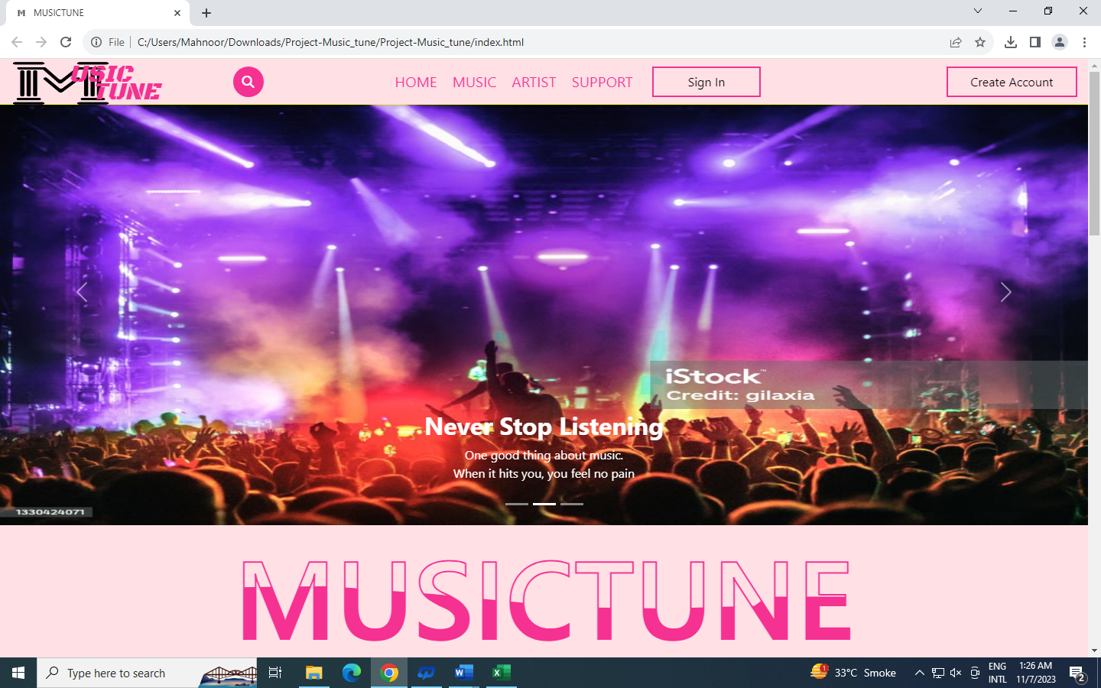

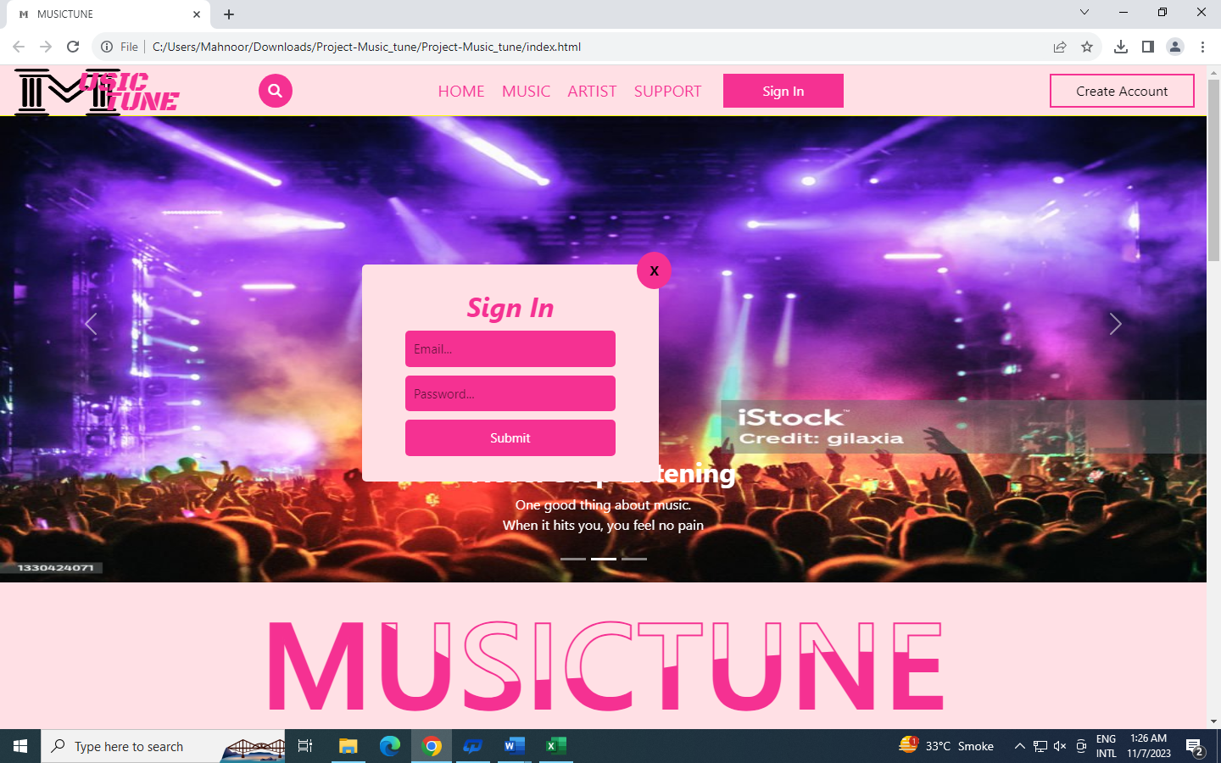

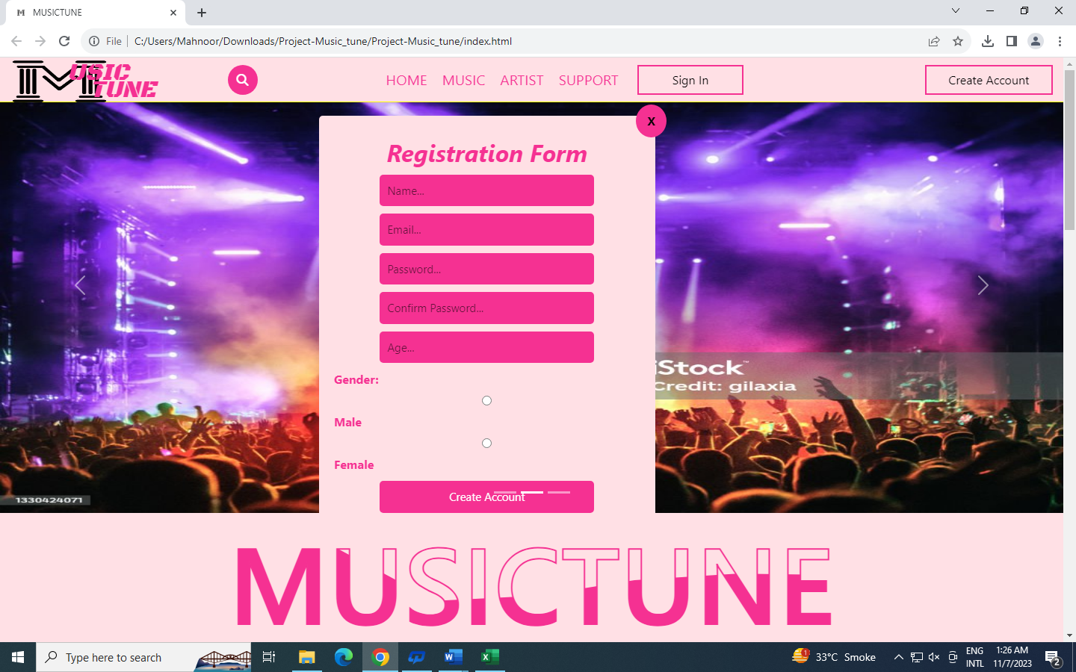

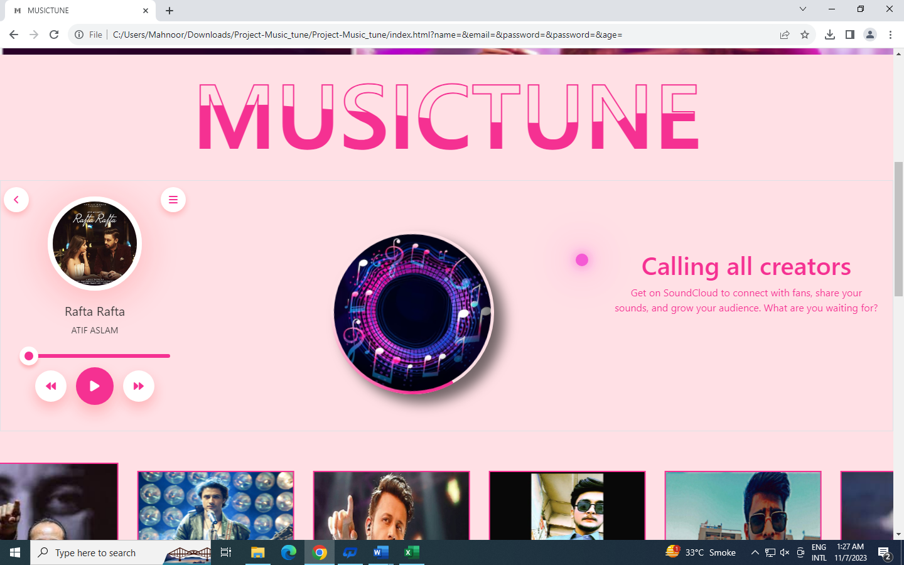

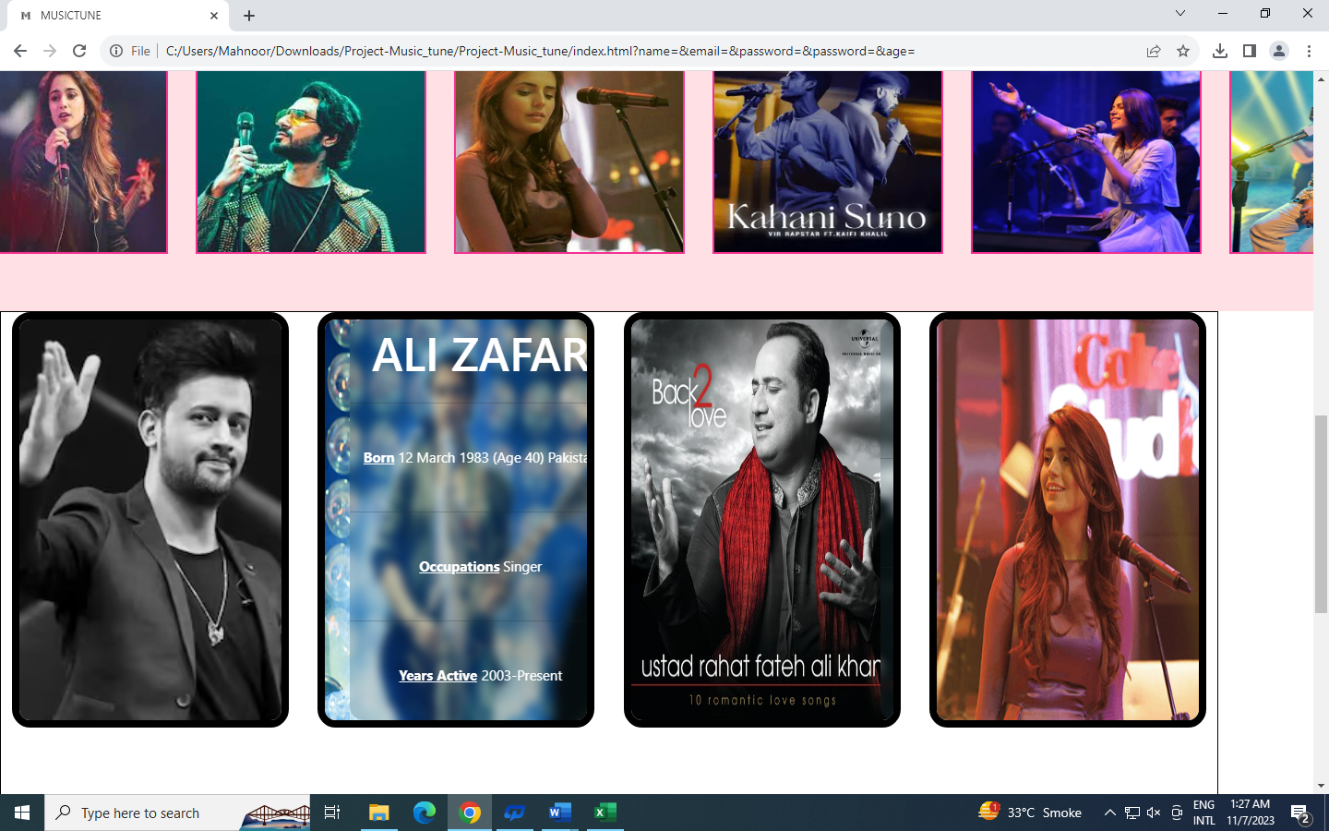

SOURCE CODE:

<!DOCTYPE html>

<html lang="en">

<head>

    <meta charset="UTF-8">

    <meta name="viewport" content="width=device-width, initial-scale=1.0">

    <title>MUSICTUNE</title>

    <link rel="icon" href="images/logo.png">

    <link href="https://unpkg.com/aos@2.3.1/dist/aos.css" rel="stylesheet">

    <link rel="stylesheet" href="main.js">

    <link rel="stylesheet" href="style.css">

    <link rel="preconnect" href="https://fonts.googleapis.com">

    <link rel="preconnect" href="https://fonts.gstatic.com" crossorigin>

    <link

        href="https://fonts.googleapis.com/css2?family=Black+Ops+One&family=Edu+TAS+Beginner:wght@400;500;600&display=swap"

        rel="stylesheet">

    <link rel="stylesheet" href="https://cdnjs.cloudflare.com/ajax/libs/font-awesome/6.4.2/css/all.min.css"

        integrity="sha512-z3gLpd7yknf1YoNbCzqRKc4qyor8gaKU1qmn+CShxbuBusANI9QpRohGBreCFkKxLhei6S9CQXFEbbKuqLg0DA=="

        crossorigin="anonymous" referrerpolicy="no-referrer" />

    <script src="https://code.jquery.com/jquery-3.7.1.min.js"

        integrity="sha256-/JqT3SQfawRcv/BIHPThkBvs0OEvtFFmqPF/lYI/Cxo=" crossorigin="anonymous"></script>

    <link href="https://cdn.jsdelivr.net/npm/bootstrap@5.3.2/dist/css/bootstrap.min.css" rel="stylesheet"

        integrity="sha384-T3c6CoIi6uLrA9TneNEoa7RxnatzjcDSCmG1MXxSR1GAsXEV/Dwwykc2MPK8M2HN" crossorigin="anonymous">

    <script src="https://unpkg.com/wavesurfer.js@7/dist/wavesurfer.esm.js"></script>

    <script src="https://kit.fontawesome.com/97ad0fdf1b.js" crossorigin="anonymous"></script>

</head>

<body>

    <div class="cursor"></div>

    <div class="nav">

        <div class="logo">

            <img class="logo-pic" src="images/Logo.png" alt="" height="190%" width="70%">

            <p class="musictune">USIC</p>

            <p class="tune">TUNE</p>

        </div>

        <div class="wrapper">

            <input type="text" class="input" placeholder="Search Here...">

            <button type="button" class="trigger_search"><i class="fas fa-search icon"></i></button>

        </div>

        <ul>

            <li><a href="#">Home</a></li>

            <li><a href="#">Music</a></li>

            <li><a href="#">Artist</a></li>

            <li><a href="#">Support</a></li>

        </ul>

        <button class="btn1">Sign In</button>

        <button class="btn2">Create Account</button>

        <form id="form">

            <h2>Sign In</h2>

            <button class="btnclose"><b>X</b></button>

            <input type="text" name="email" placeholder="Email...">

            <input type="password" name="password" placeholder="Password...">

            <input class="btn3" type="submit" value="Submit">

        </form>

        <form id="form2">

            <h2>Registration Form</h2>

            <button id="btnclose"><b>X</b></button>

            <input type="text" name="name" placeholder="Name...">

            <input type="text" name="email" placeholder="Email...">

            <input type="password" name="password" placeholder="Password...">

            <input type="password" name="password" placeholder="Confirm Password...">

            <input type="number" name="age" placeholder="Age...">

            <b>Gender:</b> <input type="radio" name="gender"> <b>Male</b>

            <input type="radio" name="gender"> <b>Female</b>

            <input id="btn3" type="submit" value="Create Account">

    </div>

    <div id="carouselExampleCaptions" class="carousel slide carousel-slide" data-bs-ride="carousel">

        <div class="carousel-indicators">

            <button type="button" data-bs-target="#carouselExampleCaptions" data-bs-slide-to="0" class="active"

                aria-current="true" aria-label="Slide 1"></button>

            <button type="button" data-bs-target="#carouselExampleCaptions" data-bs-slide-to="1"

                aria-label="Slide 2"></button>

            <button type="button" data-bs-target="#carouselExampleCaptions" data-bs-slide-to="2"

                aria-label="Slide 3"></button>

        </div>

        <div class="carousel-inner">

            <div class="carousel-item active" data-bs-interval="4000">

                <img src="images/Screenshot 2023-11-04 020602.png" class="d-block w-100" alt="...">

                <div class="carousel-caption d-none d-md-block">

                    <h2 style="color:black; font-weight: bolder;"><u>Connect on MusicTune</u></h2>

                    <p style="color:black; font-weight: bolder;">Discover, stream, and share a constantly expanding mix

                        of music from emerging

                        and major artists around the world.</p>

                </div>

            </div>

            <div class="carousel-item" data-bs-interval="4000">

                <img src="images/istockphoto-1330424071-1024x1024.jpg" class="d-block w-100" alt="...">

                <div class="carousel-caption d-none d-md-block">

                    <h2><b>Never Stop Listening</b></h2>

                    <p>One good thing about music.<br>When it hits you, you feel no pain </p>

                </div>

            </div>

            <div class="carousel-item" data-bs-interval="4000">

                <img src="images/images.jfif" class="d-block w-100" alt="...">

                <div class="carousel-caption d-none d-md-block">

                    <h2><B>The Beatles Experience</B></h2>

                    <p style="text-justify: center;">Our playlist The Beatles Experience features a diverse collection

                        of songs in mp3 format, ready

                        for you to download and enjoy without any charges or FREE of cost. With a mix of old favourites

                        and new hits, there's something for everyone. Whether you're looking for the latest chartbuster

                        songs or some classic tracks, our The Beatles Experience playlist has got you covered.</p>

                </div>

            </div>

        </div>

        <button class="carousel-control-prev" type="button" data-bs-target="#carouselExampleCaptions"

            data-bs-slide="prev">

            <span class="carousel-control-prev-icon" aria-hidden="true"></span>

            <span class="visually-hidden">Previous</span>

        </button>

        <button class="carousel-control-next" type="button" data-bs-target="#carouselExampleCaptions"

            data-bs-slide="next">

            <span class="carousel-control-next-icon" aria-hidden="true"></span>

            <span class="visually-hidden">Next</span>

        </button>

    </div>

    </div>

    <div class="animation">

        <h2>MUSICTUNE</h2>

        <h2>MUSICTUNE</h2>

    </div>

    <div class="border">

        <div class="player">

            <div class="playermusic">

                <nav>

                    <div class="circle">

                        <i class="fa-solid fa-angle-left"></i>

                    </div>

                    <div class="circle">

                        <i class="fa-solid fa-bars"></i>

                    </div>

                </nav>

                <img src="images/rafta rafta.jpg" class="song-img">

                <h1>Rafta Rafta</h1>

                <p>ATIF ASLAM</p>

                <audio id="song">

                    <source

                        src="media/Rafta Rafta - Official Music Video  Raj Ranjodh  Atif Aslam Ft. Sajal Ali  Tarish Music.mp3"

                        type="audio/mpeg">

                </audio>

                <input type="range" value="0" id="progress">

                <div class="controls">

                    <div><i class="fa-solid fa-backward"></i></div>

                    <div onclick="playPause()"><i class="fa-solid fa-play" id="ctrlIcon"></i></div>

                    <div><i class="fa-solid fa-forward"></i></div>

                </div>

            </div>

        </div>

        <div class="ani"></div>

        <div class="text">

            <h1>Calling all creators</h1>

            <p>Get on SoundCloud to connect with fans, share your sounds, and grow your audience. What are you waiting

                for?</p>

        </div>

    </div>

    <div class="slider">

        <div class="slide-container">

            <div class="slide-image">

                <img src="images/slider/img1.jpg" alt="" height="225px" width="225px">

            </div>

            <div class="slide-image">

                <img src="images/slider/img2.jfif" alt="">

            </div>

            <div class="slide-image">

                <img src="images/slider/img3.jpg" alt="" height="225px" width="225px">

            </div>

            <div class="slide-image">

                <img src="images/slider/img4.jpg" alt="" height="225px" width="225px">

            </div>

            <div class="slide-image">

                <img src="images/slider/img5.jfif" alt="" height="225px" width="225px">

            </div>

            <div class="slide-image">

                <img src="images/slider/img6.jfif" alt="" height="225px" width="225px">

            </div>

            <div class="slide-image">

                <img src="images/slider/img7.jfif" alt="" height="225px" width="225px">

            </div>

            <div class="slide-image">

                <img src="images/slider/img8.jfif" alt="" height="225px" width="225px">

            </div>

            <div class="slide-image">

                <img src="images/slider/img9.jpg" alt="" height="225px" width="225px">

            </div>

            <div class="slide-image">

                <img src="images/slider/img10.webp" alt="" height="225px" width="225px">

            </div>

            <div class="slide-image">

                <img src="images/slider/img11.jpg" alt="" height="225px" width="225px">

            </div>

            <div class="slide-image">

                <img src="images/slider/img12.jpg" alt="" height="225px" width="225px">

            </div>

            <div class="slide-image">

                <img src="images/slider/img13.jpg" alt="" height="225px" width="225px">

            </div>

            <div class="slide-image">

                <img src="images/slider/img14.jpg" alt="" height="225px" width="225px">

            </div>

        </div>

    </div>

    <div class="container">

        <div class="cards">

            <img src="images/atif aslam.avif" class="card-img" alt="">

            <div class="card-body">

                <h1>ATIF ASLAM</h1><hr>

                <p><u><b>Born</b></u> 12 March 1983 (age 40) Pakistan <hr><p>

                    <u><b>Occupations</b></u> Singer <hr><p>

                    <u><b>Years active</b></u> 2003-present</p>

            </div>

        </div>

        <div class="cards">

            <img src="images/img3.jpg" class="card-img" alt="">

            <div class="card-body">

                <h1>ALI ZAFAR</h1><hr>

                <p><u><b>Born</b></u> 12 March 1983 (age 40) Pakistan <hr><p>

                    <u><b>Occupations</b></u> Singer <hr><p>

                    <u><b>Years active</b></u> 2003-present</p>

            </div>

        </div>

        <div class="cards">

            <img src="images/Back-2-Love-Hindi-2014-20190924060930-500x500.jpg" class="card-img" alt="">

            <div class="card-body">

                <h1>RAHAT FATEH ALI KHAN</h1><hr>

                <p><u><b>Born</b></u> 12 March 1983 (age 40) Pakistan <hr><p>

                    <u><b>Occupations</b></u> Singer <hr><p>

                    <u><b>Years active</b></u> 2003-present</p>

            </div>

        </div>

        <div class="cards">

            <img src="images/Momina.png" class="card-img" alt="">

            <div class="card-body">

                <h1 style="margin-top: 25px;"> MOMINA MUSTEHSAN</h1><hr>

                <p><u><b>Born</b></u> 12 March 1983 (age 40) Pakistan <hr><p>

                    <u><b>Occupations</b></u> Singer <hr><p>

                    <u><b>Years active</b></u> 2003-present</p>

            </div>

        </div>

        <div class="cards">

            <img src="images/aima baig.jpg" class="card-img" alt="">

            <div class="card-body">

                <h1>AIMA BAIG</h1><hr>

                <p><u><b>Born</b></u> 12 March 1983 (age 40) Pakistan <hr><p>

                    <u><b>Occupations</b></u> Singer <hr><p>

                    <u><b>Years active</b></u> 2003-present</p>

            </div>

        </div>

        <div class="cards">

            <img src="images/img8.jfif" class="card-img" alt="">

            <div class="card-body">

                <h1 style="margin-top: 30px;">MUSTAFA ZAHID</h1><hr>

                <p><u><b>Born</b></u> 12 March 1983 (age 40) Pakistan <hr><p>

                    <u><b>Occupations</b></u> Singer <hr><p>

                    <u><b>Years active</b></u> 2003-present</p>

            </div>

        </div>

    </div>

    <script src="https://cdn.jsdelivr.net/npm/bootstrap@5.3.2/dist/js/bootstrap.bundle.min.js"

        integrity="sha384-C6RzsynM9kWDrMNeT87bh95OGNyZPhcTNXj1NW7RuBCsyN/o0jlpcV8Qyq46cDfL"

        crossorigin="anonymous"></script>

    <script src="https://unpkg.com/aos@2.3.1/dist/aos.js"></script>

    <script src="main.js"></script>

    <script src="music-list.js"></script>

    <script>

        AOS.init();

    </script>

</body>

</html>